City of Danbury Social Service Grants 2022-2023 Application
Due: August 31st, 2022
All questions in red will autofill based off information provide in the program profile in e-CImpact. Please update your agency profile and/or program profiles if you see any of these fields missing & you cannot edit it in the application. Please reach out to Victoria Scofield, if you have any questions.
Questions with an * are required.
Form 1: Agency Information
Organization Name * EIN *
Primary Address Line 1 * Primary Address Line 2
City * State * Zip *
Organization Phone * Organization Fax
Executive Director & Contact Information * Organization Website *
Board President/Chair Name: * (Limit up to 150 characters)
Board President/Chair Email: *
Organization Mission Statement *

Organization Social Media: *
- Facebook:
- Twitter:
- Instagram:
- YouTube:
- Other:

Primary Agency Contact for this Grant Information
Primary Contact Person for this Grant: *
Primary Contact Person Title: *
Phone Number for Primary Contact Person: *
Email for Primary Contact Person: *

Agency Narratives
Total Agency Budget for Current Fiscal Year: * (Numbers only)
Has your agency been funded by the City of Danbury in the past? * (Choose one) Yes No
Does your organization have any accreditations, licensures, certifications, affiliations? (Please list all) * (Limit up to 1,000 characters)
What type of funding request are you applying for? * (Choose one) Operating Support Program Support

What, if any, significant changes has your agency experienced in the past year or may occur within the next year? * (Select all that apply)
- No Significant Changes
- Loss of Executive Director or CEO
- New Executive Director or CEO
- Loss of Major Funding
- Acquired New Major Funding
- Merger
- Other
If you selected any of the significant changes above, please explain how they have impacted your agency this past year or may occur within the next year and how those events have or may impact client services: (Limit up to 250 characters)
Is your organization currently undergoing, been notified of, or completed a Federal, State or Regulatory Audit within the last three years? * (Choose one) Yes No
If yes, please describe the situation and if completed, attach an Executive Summary of the findings in the attachments form. * (Limit up to 4,000 characters)
List key agency partners and the specific roles they play. * (Limit up to 1,000 characters)
Describe how you use community resources (board members, volunteers, in-kind donations, corporate partnerships, etc.) to support your work and how those partnerships contribute to the success of the clients served. * (Limit up to 1,000 characters)

Diversity, Equity, and Inclusion
The City of Danbury and United Way of Western CT are committed to the support and advancement of equality in the communities we serve, and this extends to the organizations we fund. The questions below will help us ensure everyone is treated fairly.
Briefly describe how your staff and organization are becoming more education about and engaged in work toward diversity, equity, and inclusion. * (Limit up to 2000 characters)

Utilize the choices below to list how your organization supports an inclusive and welcoming environment to clients of diverse cultural backgrounds.
If other, please provide an explanation as to your processes to support diverse clients.
Programs: * (Limit up to 150 characters)
Board Members: * (Limit up to 150 characters)
Staff: * (Limit up to 150 characters)
Volunteers: * (Limit up to 150 characters)
Facilities: * (Limit up to 150 characters)
Materials (brochures, books, applications, etc.): * (Limit up to 150 characters)
Other: (Limit up to 150 characters)

Form 2: Anti-Terrorism Policy
In compliance with the spirit and intent of the USA Patriot Act and other counter-terrorism laws, the City of Danbury supports the United Way of Western Connecticut and the United Way Worldwide’s (“UWW”) compliance program and requests that each funded agency (“Organization”) certify that it is in compliance with this program.
Please complete this form in its entirety on the e-CImpact platform.

Form 3: Organization Diversity Breakdown
The City of Danbury & United Way of Western Connecticut (UWWC) are committed to the support and advancement of equality in the communities we serve, and this extends to the organizations we fund.
The UWWC defines equity as the intentional inclusion of everyone in society. Equity is achieved when systems no longer predict socioeconomic, education, & health outcomes. Therefore, we will review how your organization & programs advance racial & other forms of equity through its initiatives & leadership.
Following the approach & guidance of United Way Worldwide, we will use these questions related to diversity, equity, & inclusion to help inform grant decisions. Please note that this is only one contributing factor to many criteria being evaluation & considered in our decision-making process. Our intention is to ensure everyone is treated fairly & we feel adding the questions below to our evaluation process will help us accomplish this goal.
Officers and Staff – Racial Breakdown
 | Top Admin/CEO | % of Total (Admin/CEO) | Senior Management | % of Total (Sen. Mngmt) | Other Staff | % of Total (Other Staff)
White Non-Hispanic/Latinx |  | (This will be auto calculated) |  | (This will be auto calculated) |  | (This will be auto calculated)
Black or African American
Hispanic or Latinx
American Indian and Alaska Native
Asian
Native Hawaiian and Other Pacific Islander
Multi-Racial
Other (Please state other race if known)
Not Reported
Total
Officers and Staff - Gender
Female |  | (This will be auto calculated) |  | (This will be auto calculated) |  | (This will be auto calculated)
Male
Non-Binary
Other (Please state other gender if known)
Not Reported
Total

Board of Directors – Racial Breakdown
 | Board of Directors | % of Total Board of Directors
White Non-Hispanic/Latinx |  | (This will be auto calculated)
Black or African American
Hispanic or Latinx
American Indian and Alaska Native
Asian
Native Hawaiian and Other Pacific Islander
Multi-Racial
Other (Please state other race if known)
Not Reported
Total
Board of Directors - Gender
Female |  | (This will be auto calculated)
Male
Non-Binary
Other (Please state other gender if known)
Not Reported
Total

Form 4: Agency Attachments
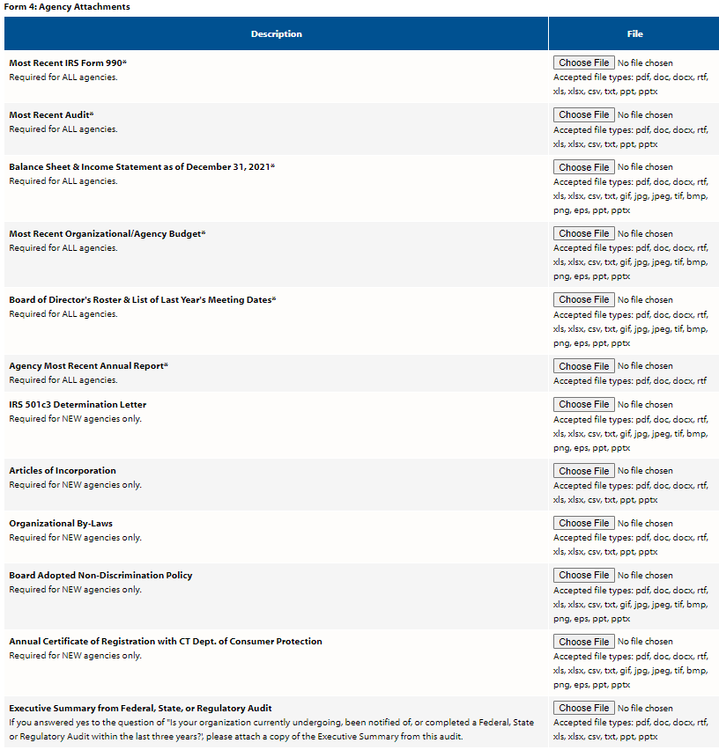
Form 5: Program Information & Narratives
Name of Program *
Program Impact Area: * Education/Child Care (Must choose either Early Ed or After-School Program Type)
(Choose one) Financial Stability (Must choose either Financial Literacy, Housing/Shelter, or Employment Program Type)
Health/Mental Health (Must choose either Health, Mental Health, or Food Security Program Type)
Program Type: * (Choose one) Early Education After-School Financial Literacy Housing/Shelter Employment Health Mental Health Food Security
Program Address* (Will autofill with Program Profile Address, but you can update if you need to)
Description of Program* (Will autofill with Program Profile description, but you can update if you need to) (Limit up to 1,500 characters)

Program Staff: (Numbers only)
Number of Full Time Staff* Number of Part Time Staff*
Number of Seasonal Staff* Number of Volunteers*

Funding Request
Funding Amount Requested: * (Numbers only)
How many clients do you currently serve? * (Numbers only)
How many clients will you be able to serve if you receive the full amount of your request? * (Numbers only)
What couldn’t your program do this year because you didn’t have the funding needed? * (Limit up to 500 characters)
If this program is unable to be funded at your full request amount, what is the minimum funding level you could accept & still be able to deliver the program successfully? * (Numbers only)
Please explain the impact a funding amount less than what is requested, or no funding would have on program delivery. Will the program be able to continue? * (Limit up to 4000 characters)

Program Narratives
Please describe the issue you seek to address with this funding. * (Limit up to 600 characters)
Describe why the City of Danbury should fund the issue you seek to address. * (Limit up to 600 characters)
Describe the target population within Danbury you will be serving with this funding. Provide available data on the target population, citing sources. * (Limit up to 600 characters)
Please indicate the percent of your clients whose income is at or below 150% of the poverty level: * (Numbers only)
Provide the objectives of your program for individuals/families who use these services. Be sure to state if your program is evidence-based. * (Limit up to 1,000 characters)
Please describe the practices you use to ensure the effectiveness of your program. Provide data that shows what you do makes a difference in the lives of your clients, citing sources. * (Limit up to 1,500 characters)
Please describe how the services supported by this funding differ from other similar services provided in the community or explain the need for multiple agencies to provide similar services. * (Limit up to 1,000 characters)
Waiting List
Do you currently have a waiting list? * (Choose one) Yes No
If yes, how long is it? * (Limit up to 150 characters)

Success Story
Please provide a story that depicts how one client improved their life as a result of your program. Please use an example from the past 12 months, and please change the client name. * (Limit up to 4,000 characters)

Form 6: Outcome Measures
State your outcome measures that you will be measuring for FY 22-23, results from the past two years and your goals for the program with City of Danbury funding. You must have at least one of each type of Performance Measure. Please refer to the ‘City of Danbury 22-23 Grant Resources’ for how to complete this form.
Result: (Please state your overall result for the program)
How Much? Performance Measure |  | Results for FY 2020-2021 | Results for FY 2021-2022 | Goals for FY 2022-2023 | Number Served July 1, 2022-December 31, 2022 | Number Served January 1, 2023-June 30, 2023
(State the Performance Measure here) | # of Clients Served or # Activities Provided |  |  |  | (For Mid-Year & Final Reports Only) | (For Mid-Year & Final Reports Only)
Describe the Performance Measure, if necessary:
How Well? Performance Measure
(State the Performance Measure here) | # of Clients Served
 | # of Clients Achieving
Describe the Performance Measure, if necessary:
Better Off? Performance Measure
(State the Performance Measure here) | # of Clients Served
 | # of Clients Achieving
Describe the Performance Measure, if necessary:

Form 7: Demographics
Please provide demographic information for the individuals served in your program during FY 2021-2022 and the estimated number to be served for FY 2022-2023.
Demographic | Number Served FY 2021-2022 | Estimated Number Served FY 2022-2023 | Number Served July 1, 2022 – December 31, 2022 | Number Served January 1, 2023 – June 30, 2023
Total Unduplicated Clients
Unduplicated Clients Served* |  |  | (You will only need to report on the first two columns during this application).
Total
Gender
Female*
Male*
Non-Binary*
Other
Unknown/Untracked
Total
Race
White Non-Hispanic/Latinx*
Black or African American*
Hispanic or Latinx*
American Indian and Alaskan Native*
Asian*
Native Hawaiian and Other Pacific Islander*
Multi-Racial*
Other
Unknown/Untracked
Total
Ethnicity
Hispanic/Latinx*
Non-Hispanic/Latinx*
Unknown/Untracked
Total
Age
0-5 years (Preschool age) *
5-10 years (Elementary School K-5 age) *
11-13 years (Middle School grades 6-8) *
14-17 years (High School grades 9-12) *
18-24 years*
25-34 years*
35-44 years*
45-54 years*
55-64 years*
65 years and over*
Unknown/Untracked
Total
Town of Residence
Danbury*
Non-Danbury*
Unknown/Untracked
Total
Income Level
Above ALICE Threshold*
ALICE Threshold*
Federal Poverty Level*
Unknown/Untracked
Total

Form 8: Program Attachments
